CESA 11 Health Notes
Health Screeners
Vision Screening Hearing Screening
This Head Start program utilizes the Welch Allyn Suresight screening tool to screen the vision of enrolled children. The screening is quick and painless and requires only minimal cooperation from the child. The vision screening is performed with a portable hand-held OAE unit. Lights and sounds are used to engage the child’s attention and the camera-like machine automatically measures and indicates if there are any abnormal readings. The unit screens for common vision problems, including near- and farsightedness (myopia/hyperopia), astigmatism (asymmetrical focus) and anisometropia (unequal power between eyes). Each eye can be screened in approximately 5 seconds.  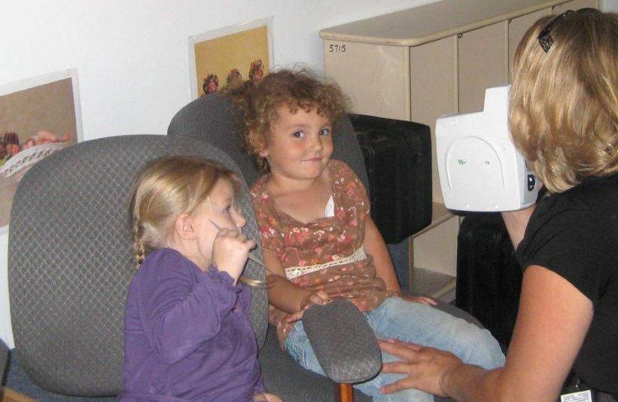 |  | This Head Start program utilizes the Ero Scan Otoacoustic Emissions (OAE) screening tool to screen the hearing of enrolled children. The screening is quick and painless and does not require a behavioral response from the child.  The hearing screening is performed with a portable hand-held OAE unit. A small, soft probe, fitted with a sensitive microphone, is placed in the child’s ear. This probe delivers a low-volume sound into the ear. The response from the inner ear is then analyzed and the results are displayed on the OAE unit as a pass or referral. Each ear can be screened in approximately 30 seconds.  